IBM Data Science Capstone Report:

Road Collisions Fatality Analysis and Prediction)

Introduction
Do you know what are the first causes of death? From Eurostat datas registered in Europe the order is cardiovascular, cerebrovascular, respiratory diseases, these one with more than 11'200'000 deaths and accidents, with about 6'700'000 deaths registered in 2016, soo far from about 300'000 from HIV and 200'000 from drug addiction. The problem with the road is that you are not able to expect what will happen, because accidents often occur due to driver distractions. However, empirical parameters can be measured through which it is possible to predict what will happen in the mean future thanks to a deterministic approach to the events. Once again the technology comes in handy thanks to the algorithm models, which if are in an adequate way, they are able to predict the risk of an accident in a determinate zone in a determinate day and time. This function might be used by several entities. Drivers could ask the on-board computer or smartphone application what is the road risk is on their journey and choose the least risky one, or if they can, postpone at another time. The police could prevent accidents by going to risk a area to exercise order and thus save even a serious accident only by doing this. Hospitals could bring ambulances to high-risk areas in advance, to be quicker in helping patients, for example to stop bleeding in time, and so on. So the business is to advise everyone who is involved in an accident, from who might was directly involved, to who is stucked in the traffic, and to the police and the ambulances, that could be prepared to be in the site before accident will happen.

DATA
The dataframe will have this fields:

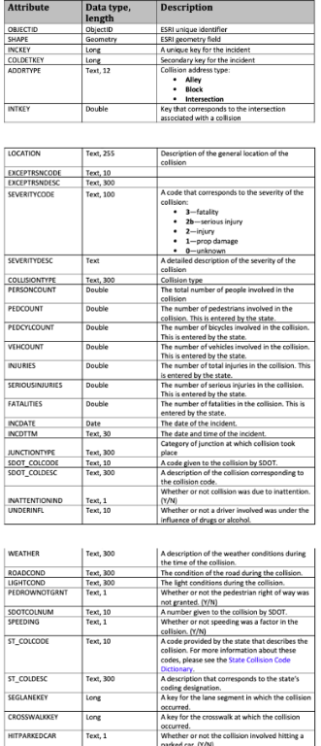

With data of over 10,000 accidents occurring every year, authorities responsible for traffic rules and regulations as well as the companies looking forward to developing techniques or in route to research for development in infrastructures, traffic system or even vehicles can benefit from the model.
The data comes from collision and accident reports in Seattle during the years 2004-present and provided by SPD(Seattle Police Department) and recorded by Traffic Records. The data will be used to identify the key variables that cause accidents. For example, the “WEATHER” column can be used to show the number of accidents that occur for different categories, such rainy, or foggy. The list of the accidents can be sorted descending to identify the more dangerous intersections that need improvements or closer monitoring. Finally, a supervised learning models will be used to come up with a formula that can predict the severity of an accident based on the inputs.
The data has 37 independent variables and 194,673 records. The dependent variable, “SEVERITYCODE”, is the target and has numbers that correspond to different levels of severity caused by the accident, but only tro of these happen in the dataset; the “prop damage” and the “injury”. Many of the columns are object types. In addition, other columns that appear to be integer types are also actually objects, because the numbers correspond to different categories. Finally, some columns and rows have null values, which will be dealt with during the data pre-processing phase.

Methodology
Exploratory data analysis was performed on the relevant categorical variables: address type, junction type, weather, road conditions, light conditions, the day extracted by the data and the time. The amount of categories in each variable ranged from a few to over a dozen. As a result, categories with less than a dozen variables were turned into countplots to better visualize the data. Statistical and correlation testing was not performed because the data revolved around categorical variables, not numerical ones.
Unfortunately, key variables such as pedestrian right of way, inattentive drivers, and whether the car was speeding had a majority of null values. Therefore, they were dropped and not part of the analysis. However, it is likely that these variables play a key factor in vehicle accidents.

results
Interestingly, the data shows that most accidents occur during the day with normal drivers and conditions.
To start with, here is a plot for the dependent variable:
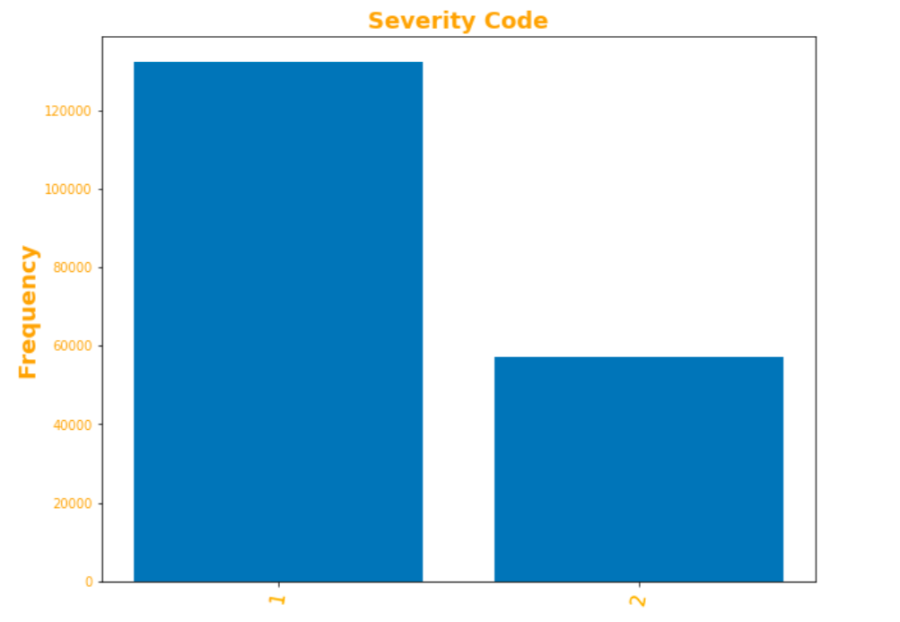
Most of the cases involved property damage.

The first variable involves where accidents took place:
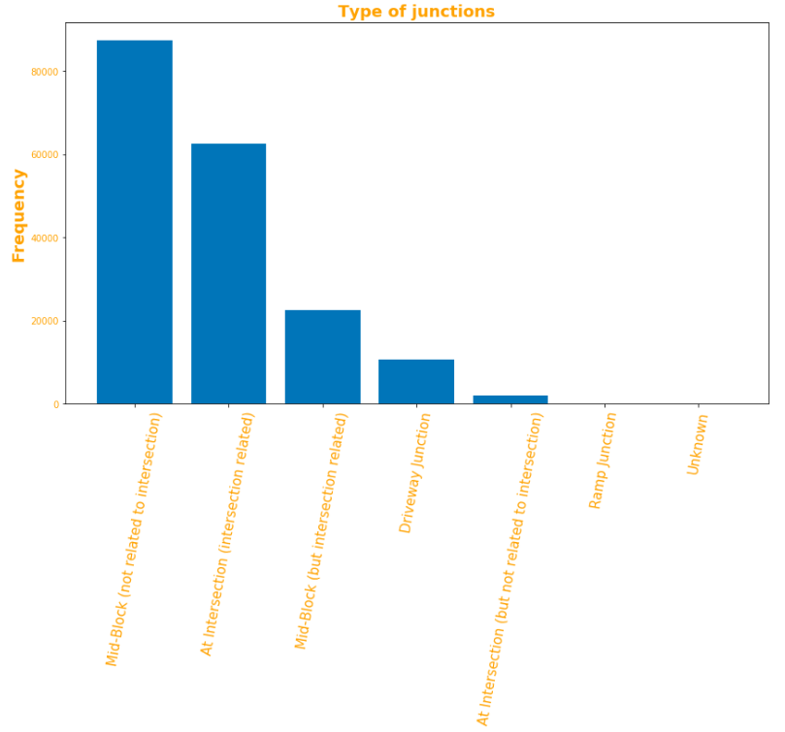

As expected, most occur at a block, we can see that or in a mid-block, or in the proximity of an intersection the risk is higher than elsewhere.

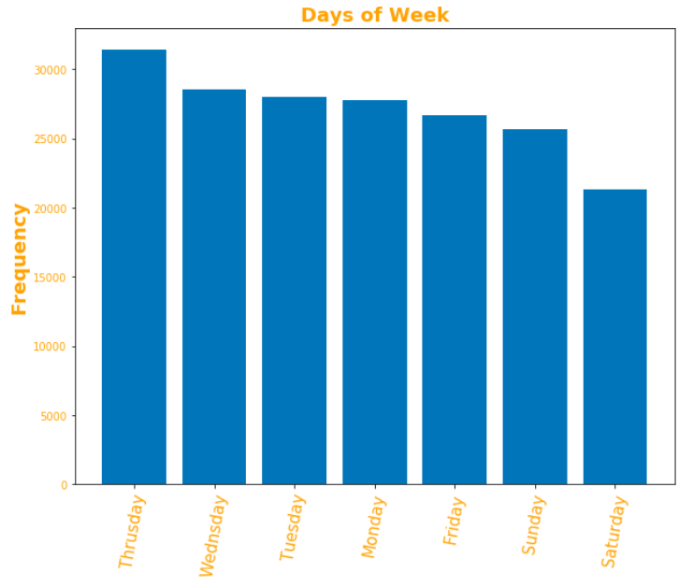

The above chart shows the days of collisions. As not like I expected the highest category involves in the week days.

Next, analysis was done on certain uncontrollable factors such as weather and road conditions:
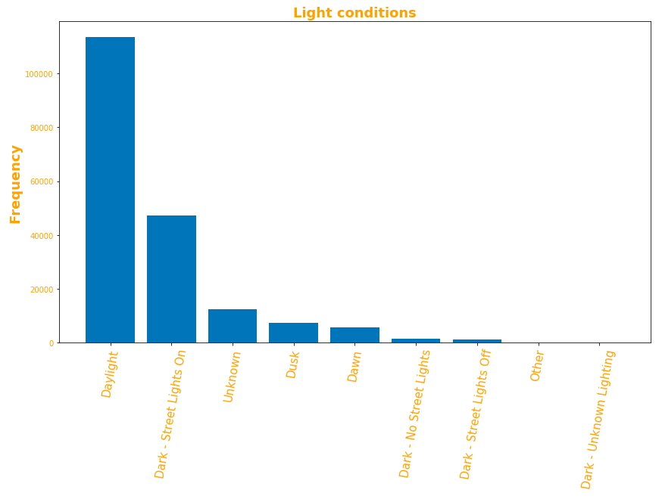

We can see that most of accidents happen on the daylyght or when there are the street lights on.
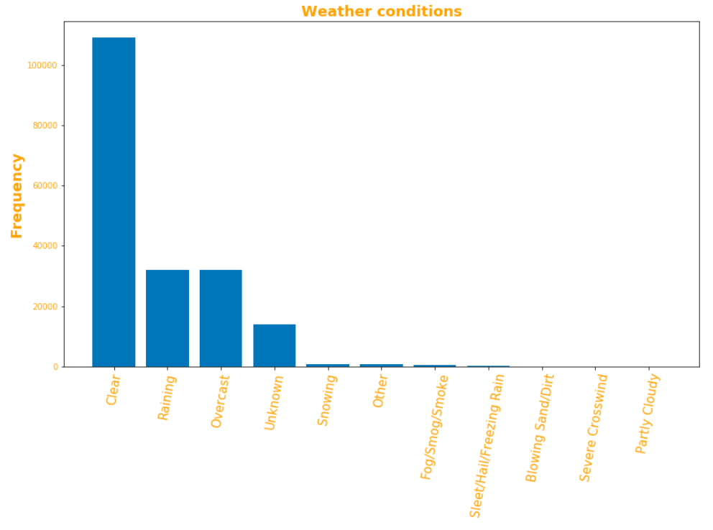
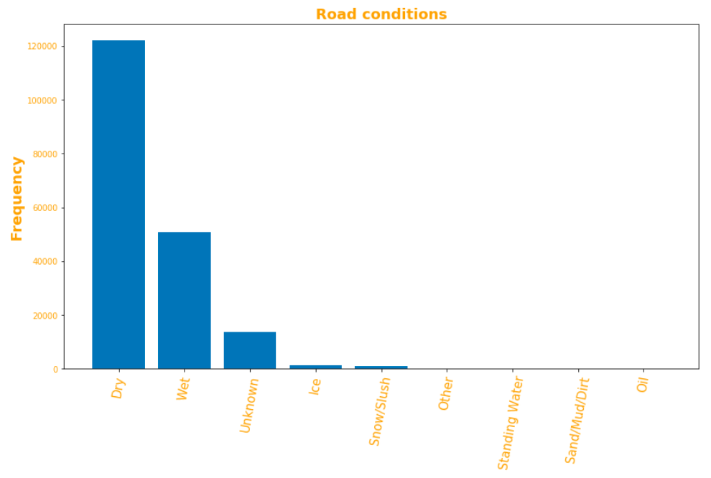
Most vehicle accidents occur during the best driving times when it is clear, during the day, and the roads are dry, but also wet asphalt is quite influencing.
Finally, here is a plot for the location:
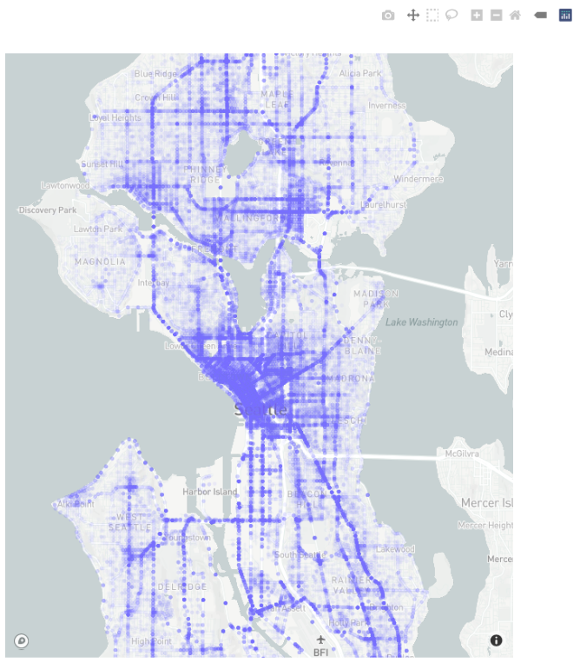
We can see that the busiest roads have reported the largest number of accidents, so the accident’s location could be an independent variable and we'll put into our model
Model & Results
Upon creating and training the model, we were able to test our model with the whole dataset and that is 189339 accidents, where the input features were the conditions the accidents occurred at and we were able to get an accuracy of up to 69%.

DISCUSSION
The first striking observation has to do with the dependent variable. It seems highly unlikely that over the date range of the data no serious injuries or fatalities occurred. This may be a warning sign that the severity codes were somehow altered when the data set was being created, or that the sample data is incomplete and missing those reports. It was determined that most accidents occur during normal weather and road conditions, but only because these days constitute the highest number of days in the year. For example, it may be sunny for 100 days and then snow on 1 day. Really, the average number of accidents per weather type is much higher on snowy days. Though, because there are few days like that during the year the total number of accidents appears low. Therefore, further data on the weather needs to be analyzed, maybe standardizing the dataframe by those conditions.

CONCLUSION
We saw that road conditions play a vital role where we thought driving in the weekends would be a bigger factor, we saw that the busiest have reported the largest number of accidents, we saw that some weather conditions which do not seem harmful play a larger role in vehicle collisions.
The fact that most vehicle accidents occur during good conditions with normal drivers, this means it will be harder for transportation department to mitigate accidents. However, as most accidents only involve minor injuries, is a positive signal.

